HIVE CHALLENGE 1

1. Download vehicle sales data ->

https://github.com/shashank-mishra219/Hive-Class/blob/main/sales_order_data.csv

2. Store raw data into hdfs location

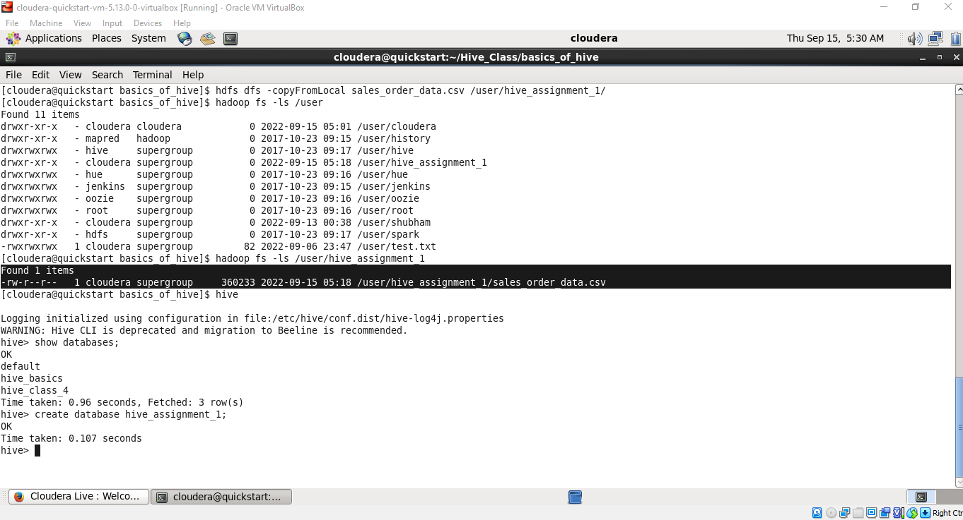

3. Create a internal hive table "sales_order_csv" which will store csv data sales_order_csv .. make sure to skip header row while creating table

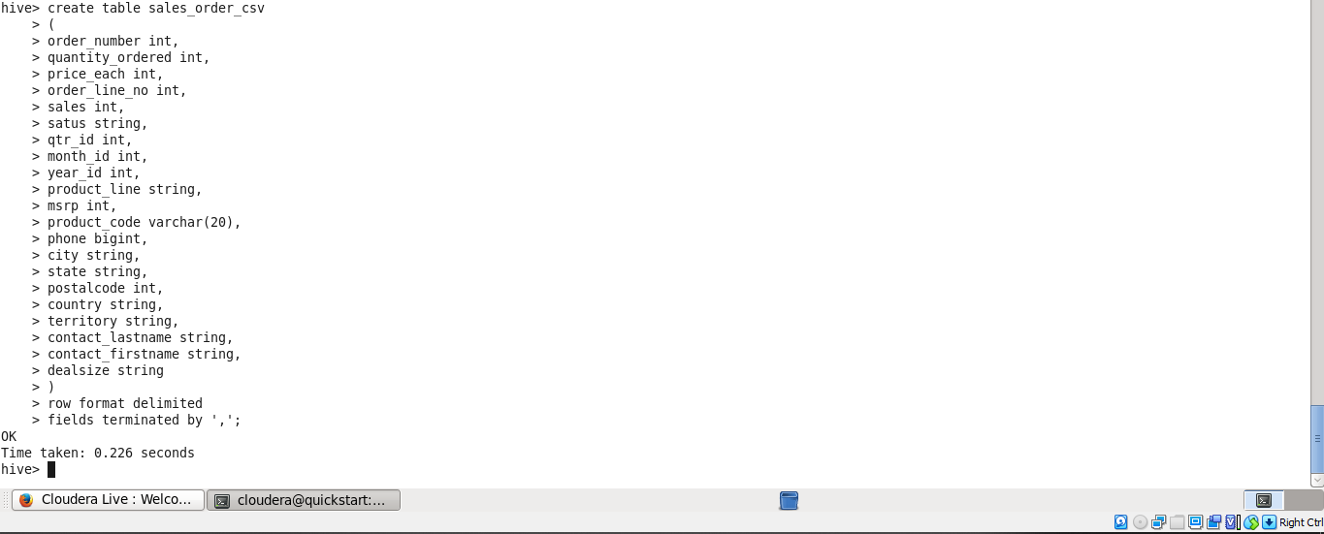

4. Load data from hdfs path into "sales_order_csv"

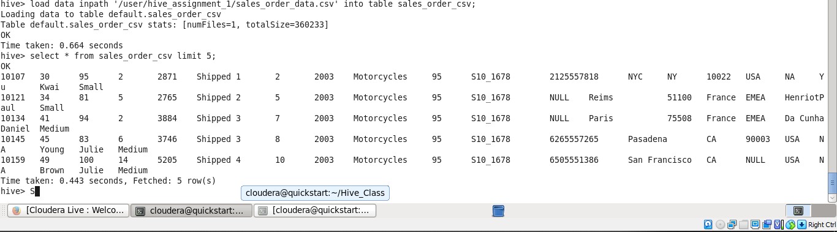

5. Create an internal hive table which will store data in ORC format "sales_order_orc"

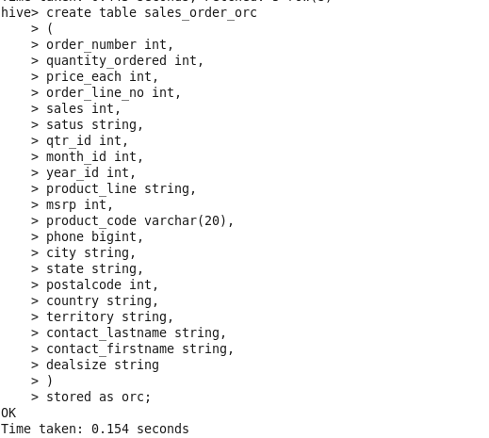

6. Load data from "sales_order_csv" into "sales_order_orc"

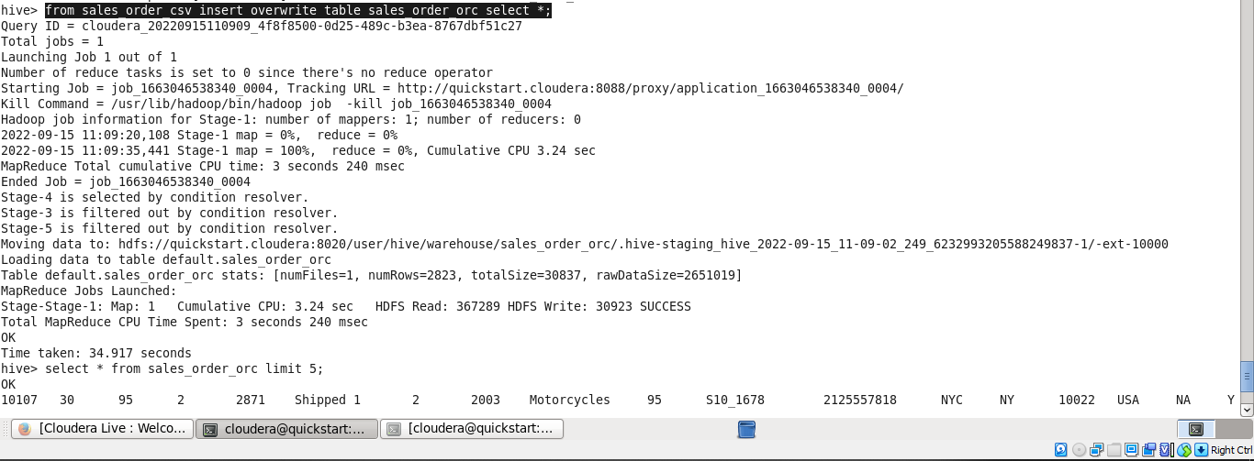

Perform below mentioned queries on "sales_order_orc" table :show

a. Calculate total sales per year

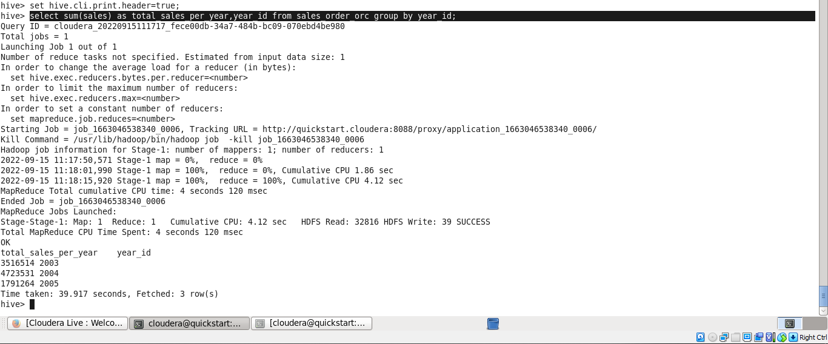

b. Find a product for which maximum orders were placed

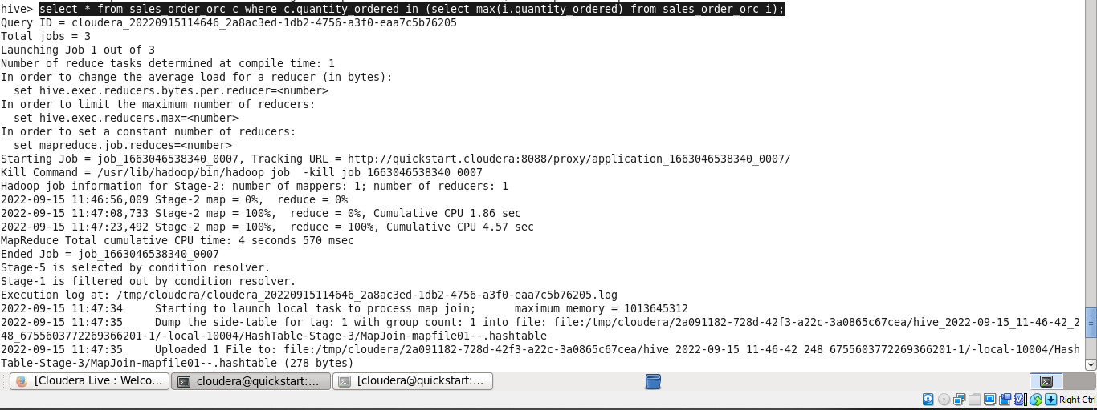

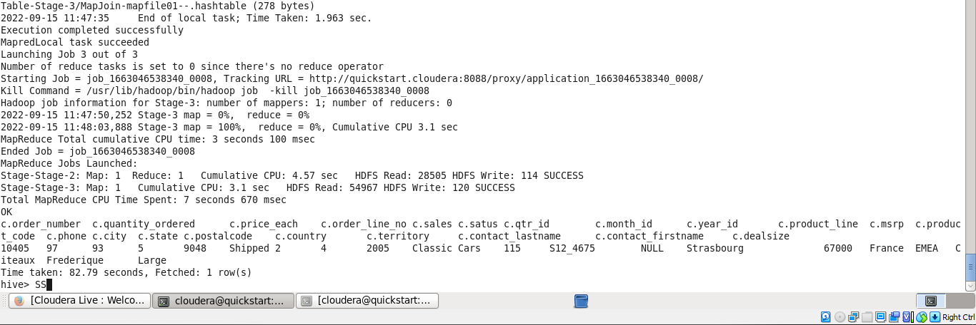

c. Calculate the total sales for each quarter

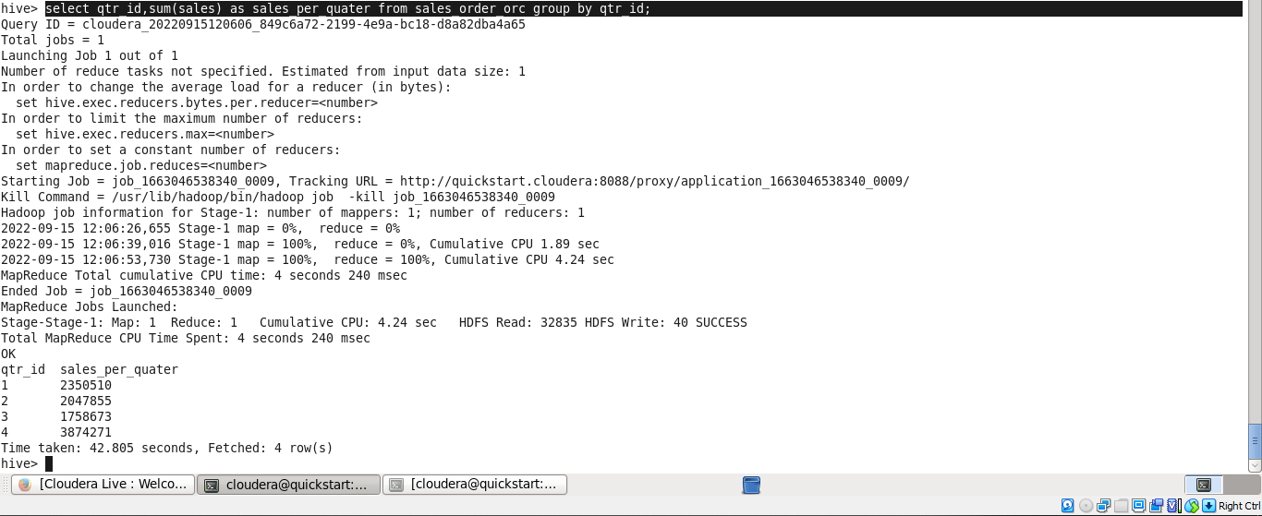

d. In which quarter sales was minimum

Step 1: aggregate the sales group by quarter

Step 2 : find quarter having min sales

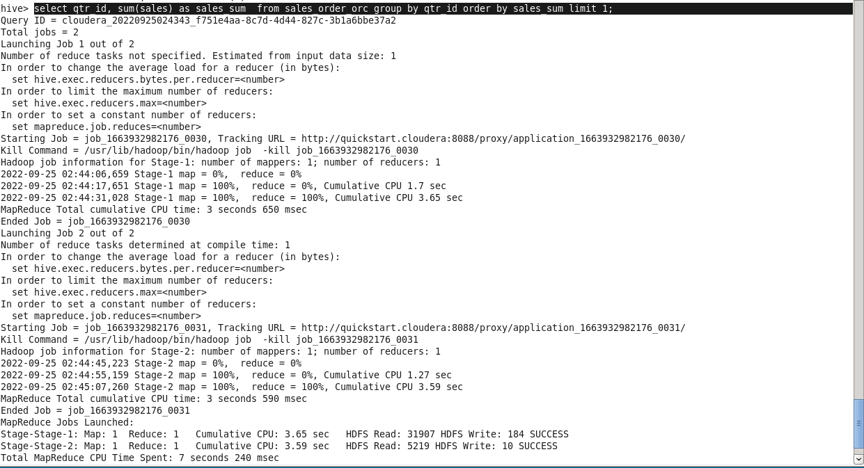

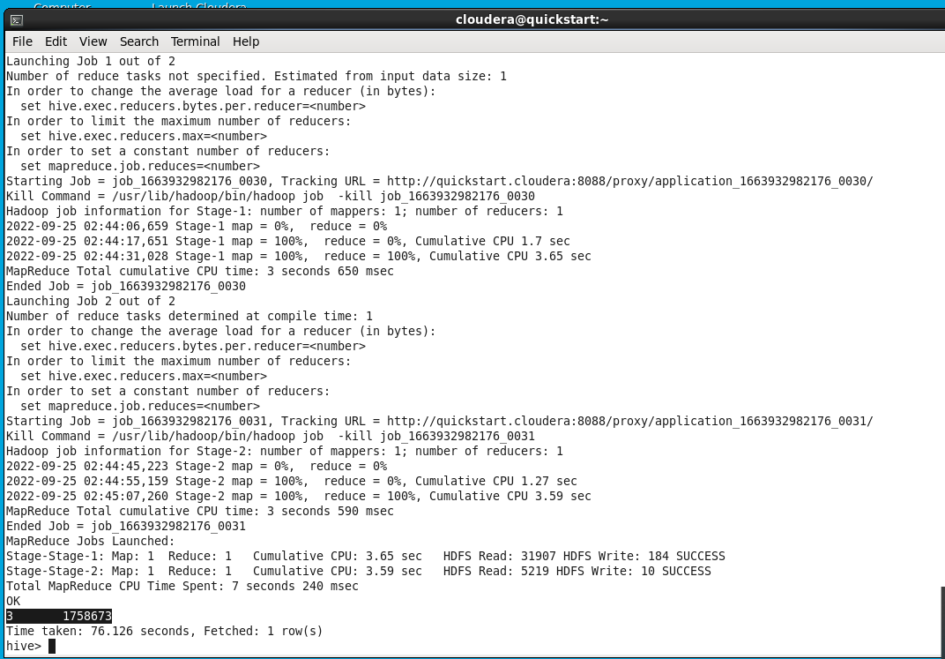

e. In which country sales was maximum and in which country sales was minimum

step 1: find sales data group by country

step 2: find country having min(sales)

WAY 1: using group by and order by in same query

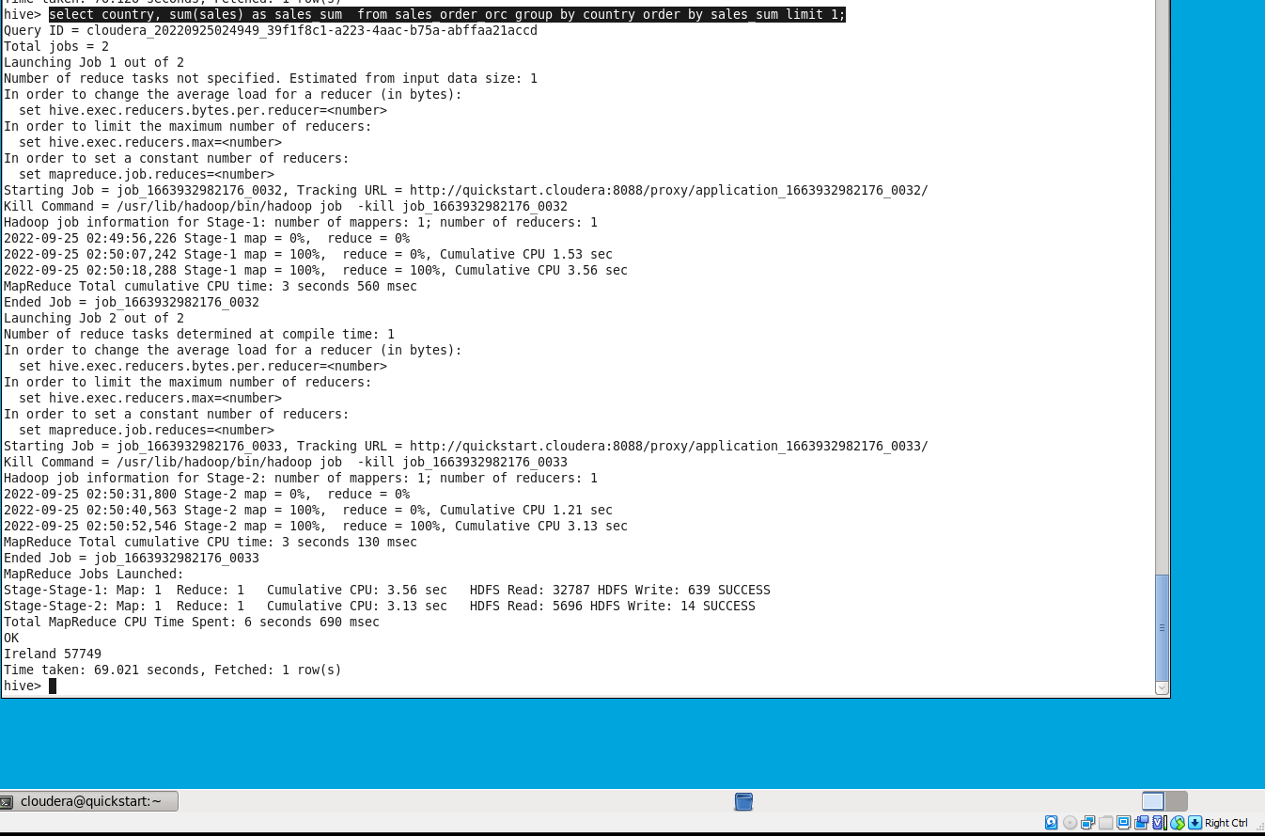

WAY 2: using the harder way

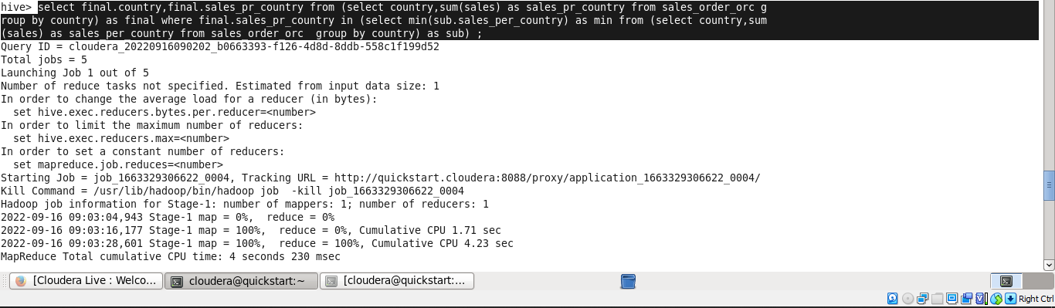

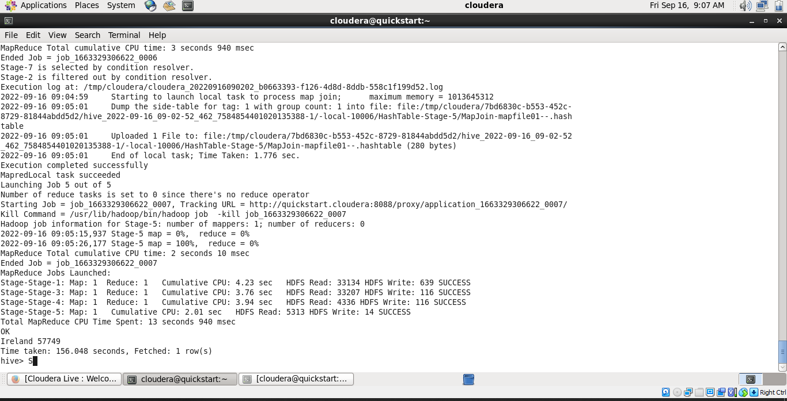

f. Calculate quartelry sales for each city

step 1: find quarterly sales

step 2: group by city

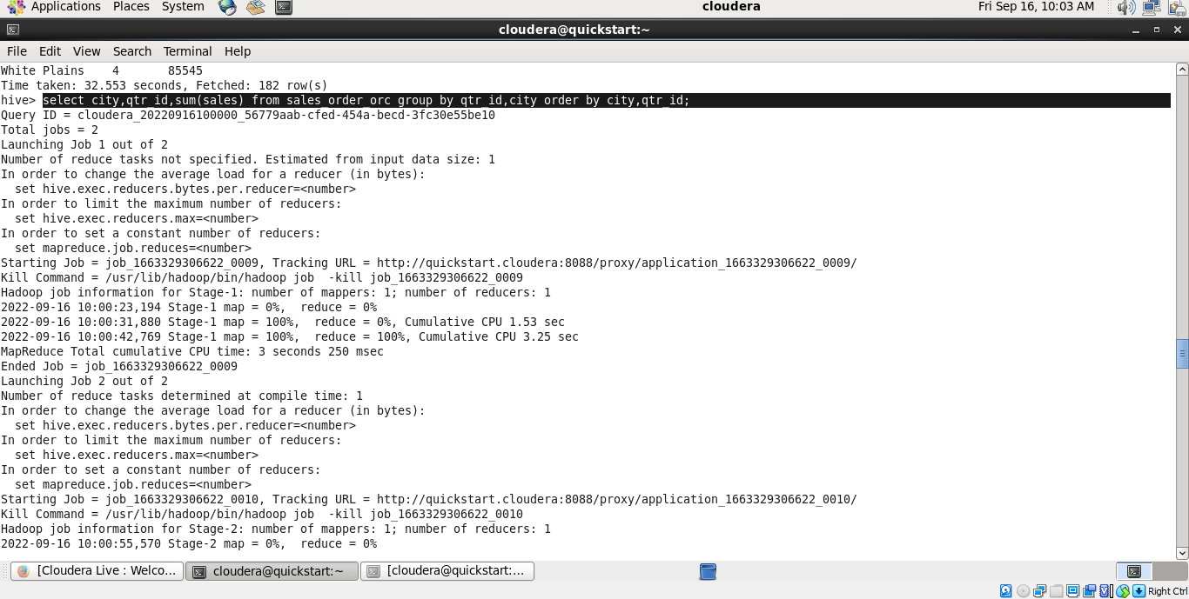

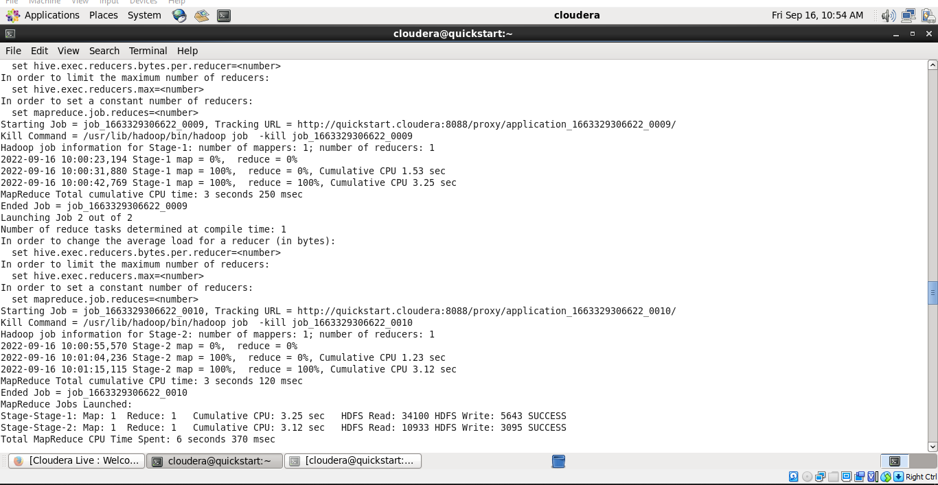

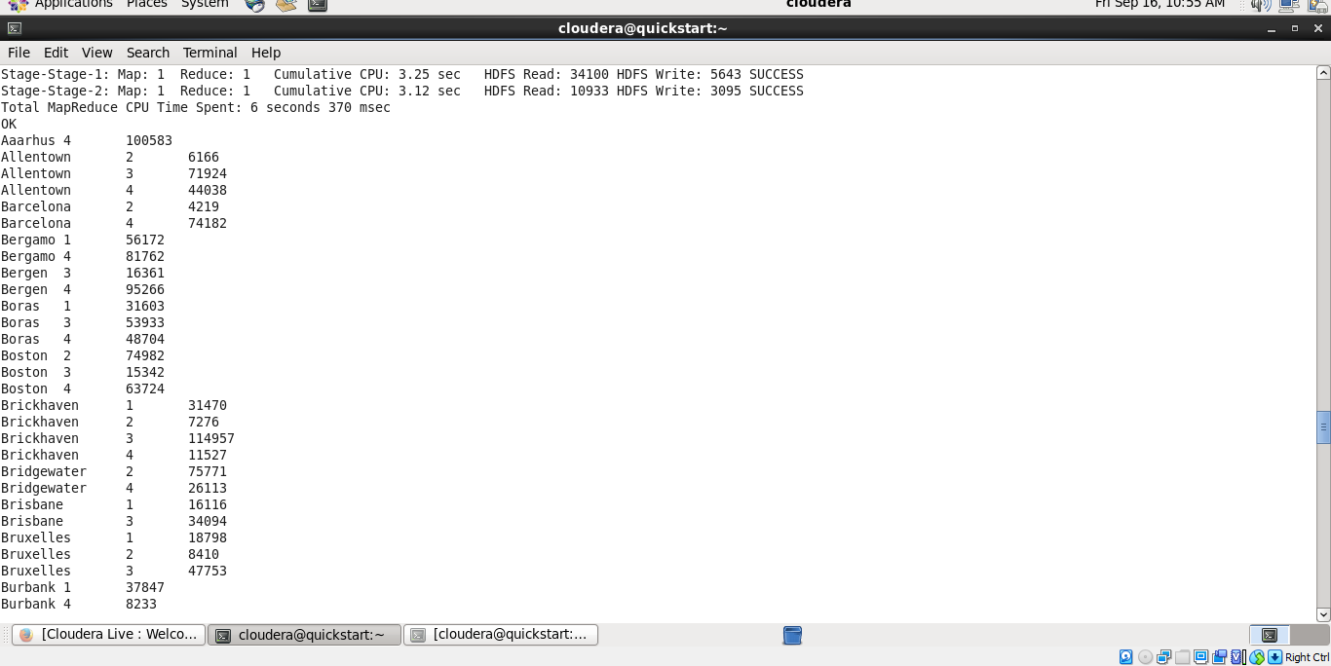

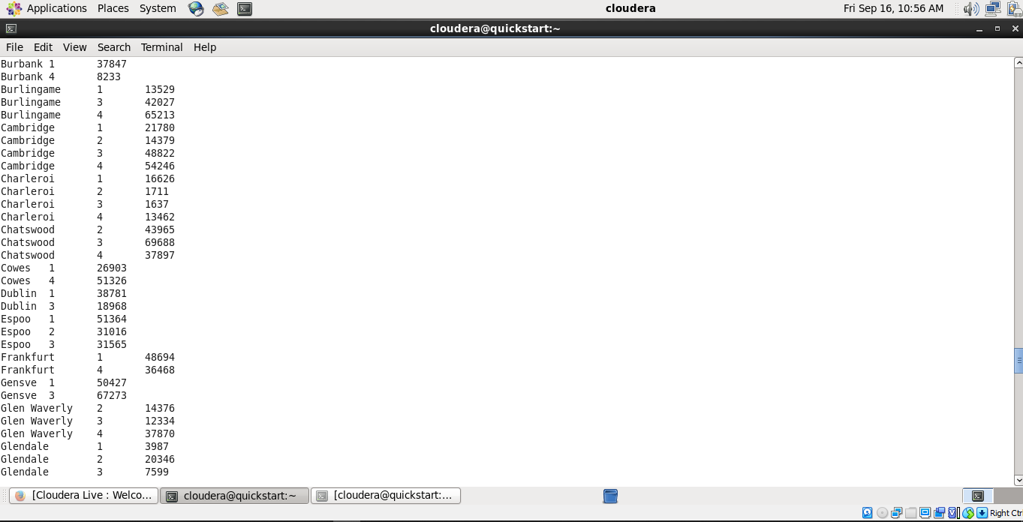

h. Find a month for each year in which maximum sales happened

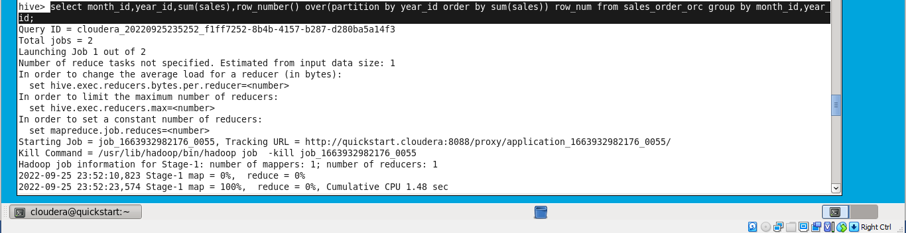

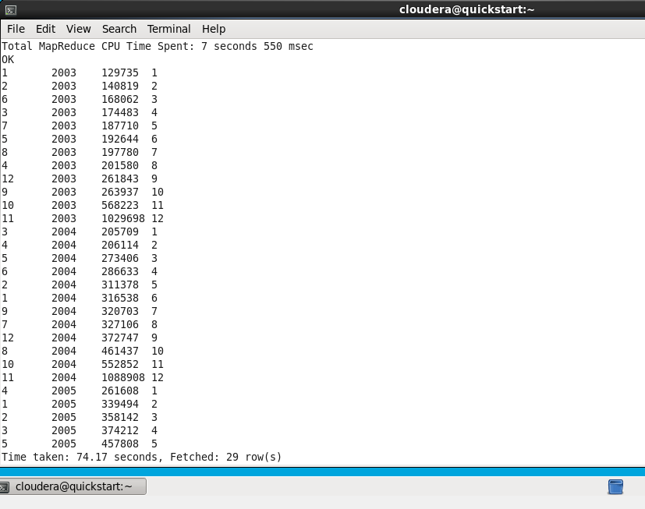

The Final Filtering on this intermediate output:

